It is to be informed that on 13/03/2023, Idea Thon 2023 was organized under Student Start Up and Innovation. Out of the total 61 start up project titles, 50 start up presentations were taken in this event.
Finally the result was declared and the first 3 students were encouraged by prizes and certificates. The event was organized by Darbar Rajendra Singh (Coordinator of Student Start Up and Innovation).
Honorable Pro Vice Chancellor Dr. Kalpesh Wandra, Pro Vice Chancellor Dr. Aqeel Ali Saiyed, Registrar Dr. Himmatsinh Rajput were present during the presentation. Every institute vice coordinator was present in this event. At the end of the result the information about the 3 students who came first 3 is as follows is
Sr. No | Students Name and College Name | Idea Thon Tital | Rank | Price
1 | Jaydeepsinh solanki-BCA | Taluka panchayat web site devlopment | First | 10,000
2 | Shraddha Thakor -Gokul Global college of commerce and management | Water tank cleaning methods | Second | 5,000
3 | Rikunj Suthar-Hansaba college of engg and technology | Production of NaCl02 and Acetic Actic Acid | Third | 3,0000

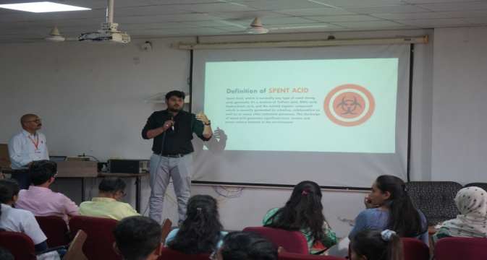 | 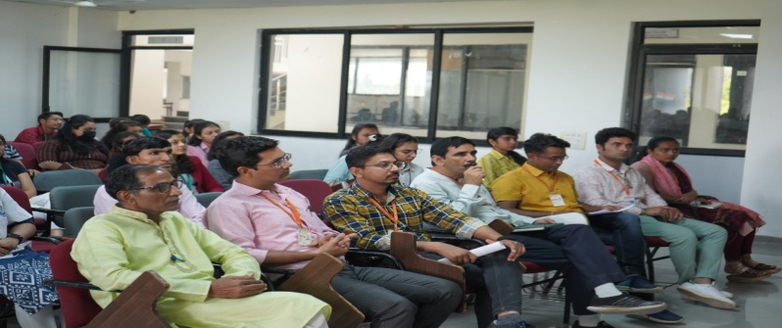
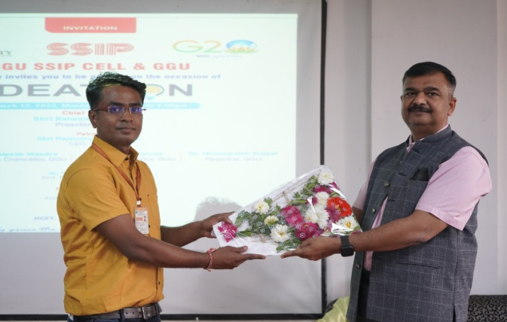 | 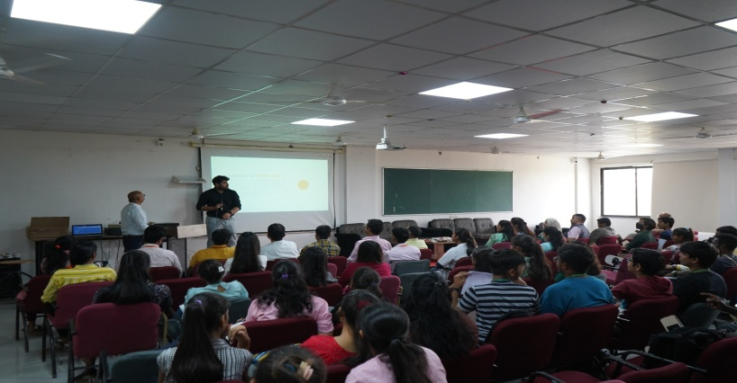
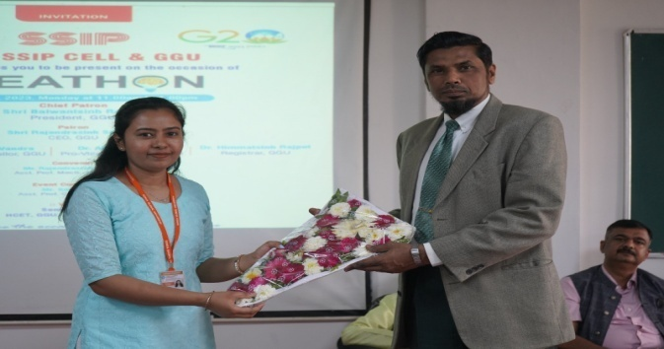 | 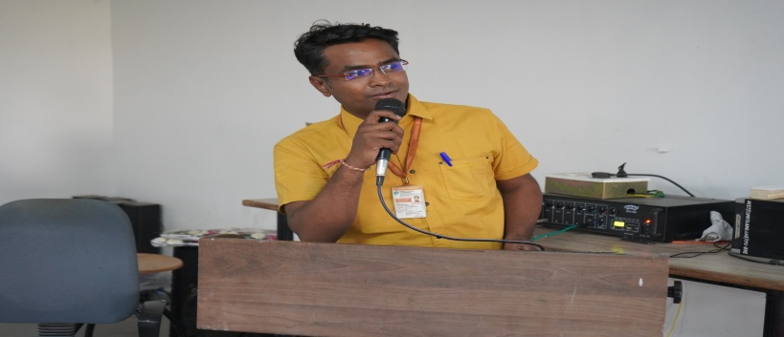
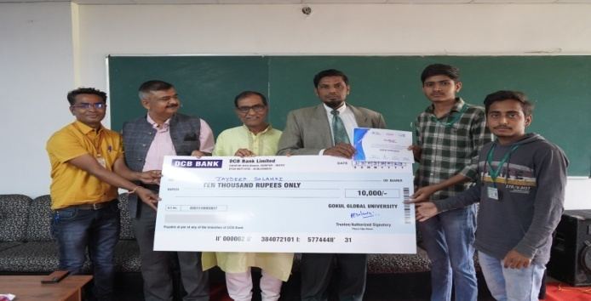 | 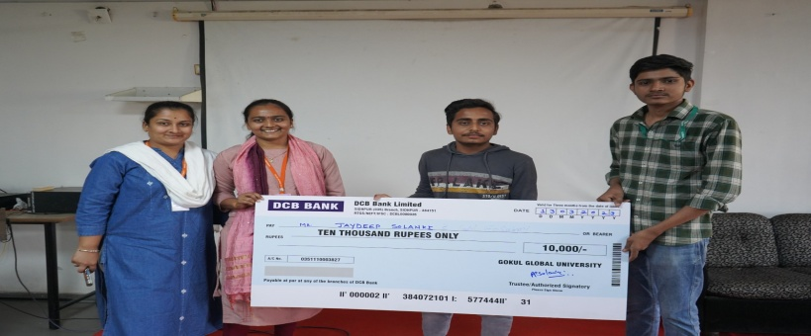
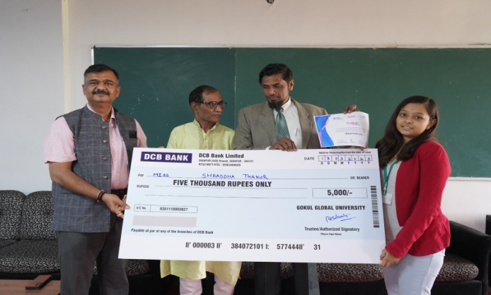 | 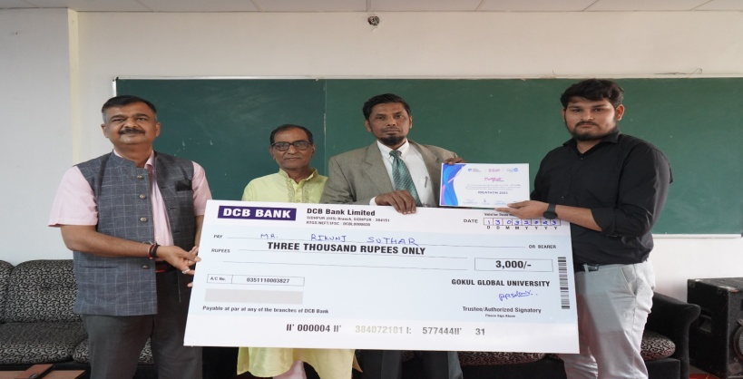
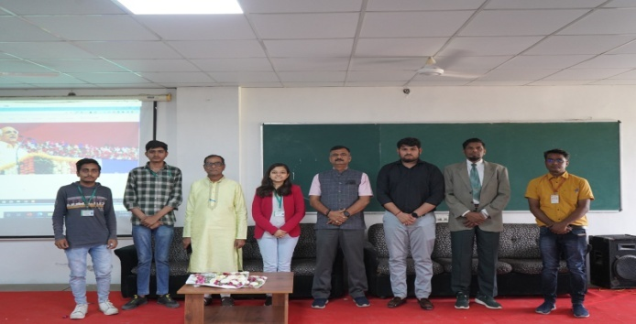 | 